Dogeons and DragonsFinal Project Documentation Draft

1. Project Vision
   1. Backgrounds
      1. Donovan Cummins
         1. Likes design and project planning. Not good at either.
   2. Socio-economic Impact, Business Objectives and Gap Analysis
      1. Socio-economic Impact
         1. A mobile digital recreational activity to elevate a users mood or distract from a users stress.
      2. Business Objectives
         1. Reach as many users as possible.
         2. Retain users who use the app.
         3. Achieve user and critical acclaim on all aggregate review platforms.
      3. Gap Analysis
         1. A continuous cycle of development based on user feedback and market trends.
   3. Security and Ethical Concerns
      1. Security
         1. User account information must be protected with the minimum required information security standards, at all times.
      2. Ethical Concerns
         1. PETA considering our application to be insensitive or promoting violence to animals.
         2. Impact of seeing cute animals in combat.
         3. People becoming addicted and playing more than is healthy for them.
   4. Glossary of Key Terms
2. Project Execution and Planning
   1. Team Information
      1. John Jaklic (IT Major)
         1. jjaklic@oakland.edu
      2. Joe Waldrup (IT Major)
         1. jwaldrup@oakland.edu
      3. Austin Kue (CS Major)
         1. kue@oakland.edu
      4. Olivia Krafft (CS Major)
         1. olkrafft@oakland.edu
      5. Loi Huynh (CS Major)
         1. loihuynh@oakland.edu
      6. Donovan Cummins (IT Major)
         1. dcummins@oakland.edu
      7. Marcel Jonas (IT Major)
         1. mjonas@oakland.edu
   2. Tools and Technology
      1. ProjectLibre (Open Source Project Management and Tracking)
      2. ModelIO, MS Visio, etc… TBD (Design Diagrams/UML)
      3. MS Powerpoint (Project Presentations)
      4. MS Word (Project Documents)
      5. Android Studio (Android App SDK)
         1. Java
      6. Unity (Graphical Game SDK)
         1. C#
      7. Blender (Open Source 2D/3D Graphical Asset Creator)
      8. Adobe Photoshop (2D/3D Graphical Asset Creator)
      9. Python (For Testing)
      10. Web Development Tools
          1. Brackets, Dreamweaver, Photoshop, Gimp, Visual Studio, etc… TBD
          2. HTML, Bootstrap, PHP, JSP
   3. Project Plan

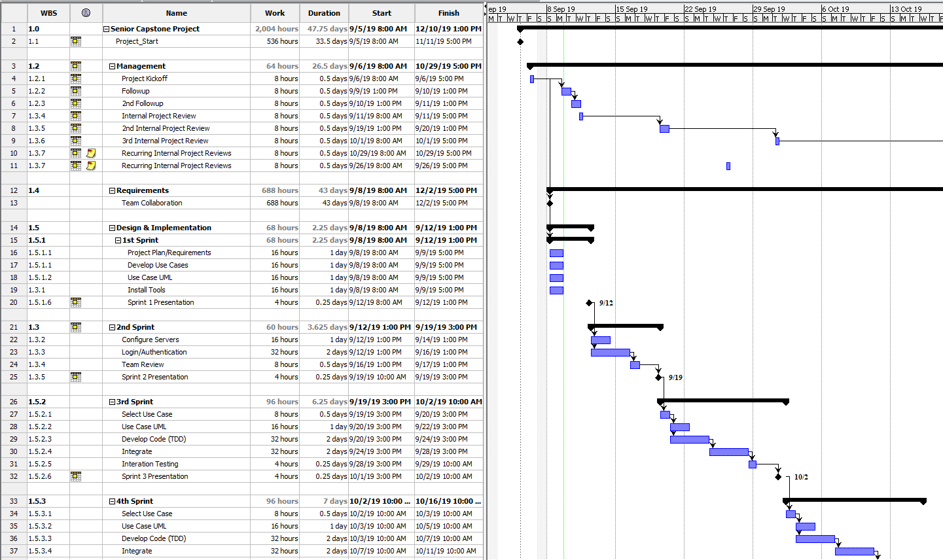

* 1. Best Standards and Practices
     1. Well documented
        1. UML Diagrams
           1. Use Case
           2. Activity
           3. Sequence
           4. Class
           5. Relationship
     2. Easy to read code
        1. Well commented
        2. Consistent casing
        3. Easy to understand Classes and Methods
     3. Object Oriented Principles
        1. Inheritance
        2. Abstraction
        3. encapsulation
        4. polymorphism

1. System Requirement Analysis
   1. Function Requirements
      1. System shall use a RMDBS for all persistent data stores.
      2. System shall Authenticate a Player.
      3. System shall let a Player start a new game.
      4. System shall offer Levels of increasing difficulty.
      5. System shall allow the Player to purchase Treasure Packs.
      6. System shall allow the Player to collect Units.
      7. System shall allow the Player to collect Items.
      8. System shall allow the Player to equip items to Units.
      9. System shall provide the Player with a persistent Inventory.
      10. System shall allow the Player to select active Units on a per Level basis.
      11. System shall allow the Player to select Chewable Items on a per Level basis.
      12. System shall save the Players Progress.
      13. System shall save the Players Score after each Win or Lose.
      14. System shall allow the Player to return to the last completed Level.
      15. System shall allow the Player to view their top Scores.
      16. System shall allow the Player to view completed Levels.
      17. System shall allow the Player to view incomplete Levels.
      18. System shall allow the Player to collect Soft Currency.
      19. System shall allow the Player to purchase Hard Currency.
      20. System shall allow the Player to view their Inventory.
      21. System shall allow the Player to purchase items with Soft/Hard currency.
      22. System shall award item and unit rewards after each completed Level.
   2. Non-functional Requirements
      1. System shall be easy to use. (measured by user feedback)
         1. Product Requirements
         2. Usability Requirements
      2. System shall control access to data.
         1. External Requirements
         2. Privacy Requirements
      3. System shall use industry standards.
         1. Organizational Requirements
         2. Standards Requirements
      4. System shall be usable without an internet connection.
         1. Usability Requirements
   3. On-Screen Appearance of Landing and Other Page Requirements
   4. Wireframe Designs
2. Functional Requirements Specification
   1. Stakeholders
      1. The Players
      2. Google
      3. Oakland Express (Development Team)
      4. Banks, Credit Card Companies, Paypal
   2. Actors and Goals
      1. The Players
         1. We want them to strive to collect, play and win with the highest score.
   3. User Stories, Scenarios and Use Cases
      1. A player will be authenticated by their device’s via default Google Play Account.

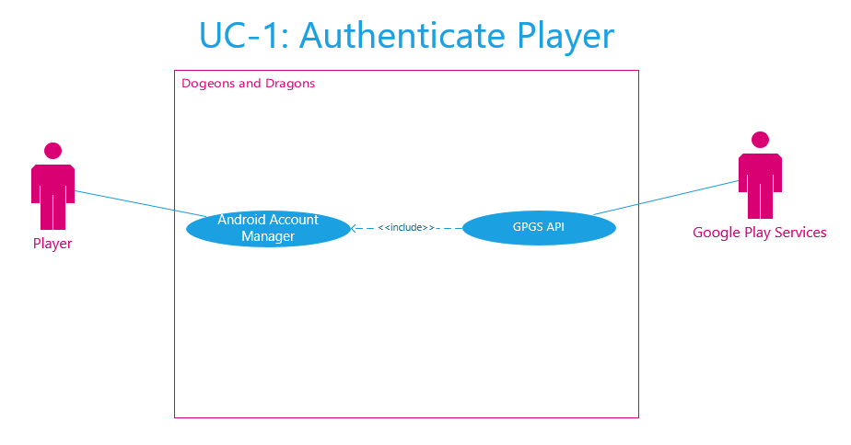

* + 1. A player is able to create a new game.
    2. A player is able to view credits.
    3. A player’s score will be saved to Google Play Services.
    4. A player is able to view a Leaderboard with their saved scores from Google Play Services.
    5. A player will have an inventory.
    6. A player will be able to view their inventory.
    7. A player will be able to select units to use for a battle.
    8. A player will be able to equip items to units.
    9. A player will be able to select chewables to use during a battle.
    10. A player will be rewarded with new unit(s) after a battle victory or from a booster pack.
    11. A player will be rewarded with new equipable item(s) after a battle victory or from a booster pack.
    12. A player will be rewarded with new chewable item(s) after a battle victory or from a booster pack.
    13. A player will progress to harder battles after each battle victory.
    14. A player can replay a level they lose on.
    15. A player will be able to view completed battles.
    16. A player will be able to view incomplete battles.
    17. A player will be able to collect soft currency after a battle victory.
    18. A player will be able to purchase hard currency.
    19. A player will be able to purchase items (units, chewables, equipment) with soft or hard currency.
    20. A player can return to the point in the game they were at, after exiting the game.
    21. A player is able to download Dogeons and Dragons from Google Play store.
  1. System Sequence / Activity Diagrams
     1. UC-1 Activity Diagram

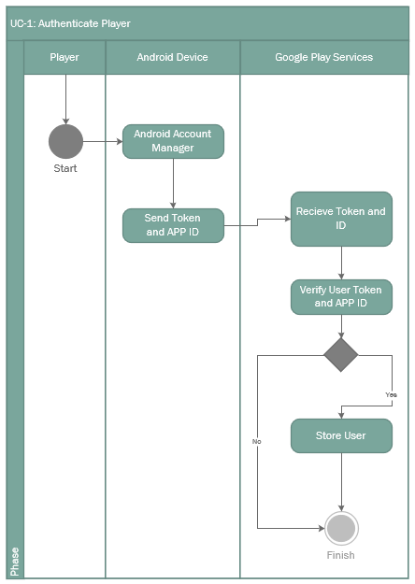

1. User Interface Specifications
   1. Preliminary Design
   2. User Effort Estimation
2. Static Design
   1. Class Model
   2. System Operation Contracts
   3. Mathematical Model
   4. Entity Relation
3. Dynamic Design
   1. Sequence Diagrams
   2. Interface Specification
   3. State Diagrams
4. System Architecture and System Design
   1. Subsystems / Component / Design Pattern Identification
   2. Mapping Subsystems to Hardware (Deployment Diagram)
   3. Persistent Data Storage
   4. Network Protocol
   5. Global Control Flow
   6. Hardware Requirement
      1. Android Based Mobile Device
5. Algorithms and Data Structures
   1. Algorithms
   2. Data Structures
6. User Interface Design and Implementation
   1. User Interface Design
   2. User Interface Implementation
7. Testing
   1. Unit Test Architecture and Strategy/Framework
   2. Unit Test Definition, Test Data Selection
   3. System Test Specification
   4. Test Reports per Sprint
8. Project Management
   1. Project Plan
   2. Risk Management
9. References